Rain Water Haresting

Collecting water from Roof Top

Can be done in Gudyari house, in farm near borewell, and in kharora house

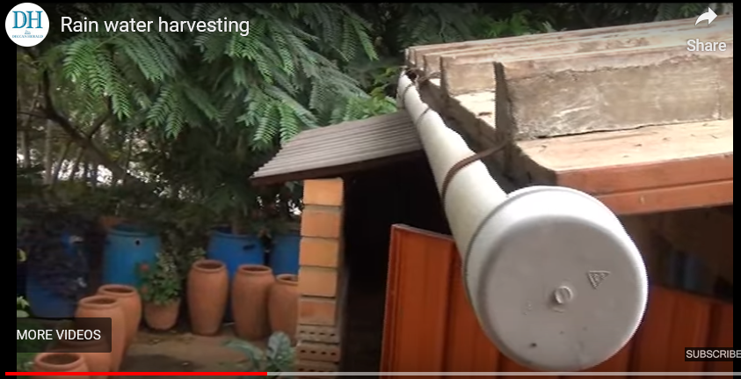

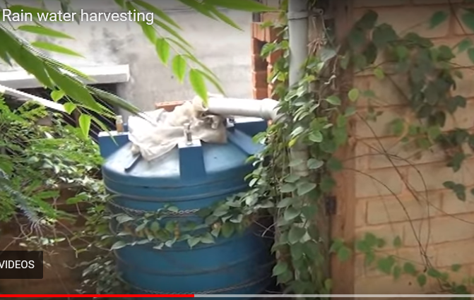

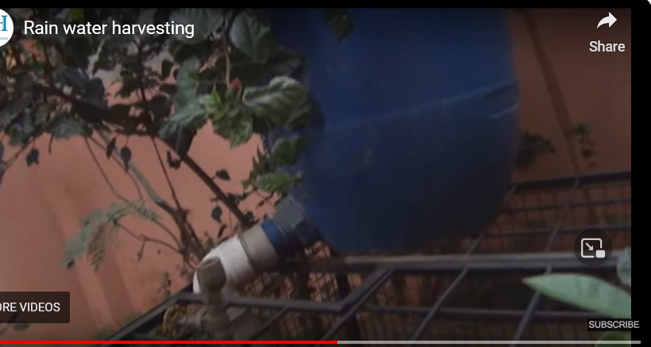

Source : <https://www.google.com/search?q=rain+water+harvesting&client=firefox-b-e&sxsrf=AJOqlzVJGSZmgBt_PSBD7vWBrEWw9j-jsA:1679684194491&source=lnms&tbm=vid&sa=X&ved=2ahUKEwi9gP2dn_X9AhUBLOwKHet7CPkQ_AUoAnoECAIQBA&biw=1536&bih=711&dpr=1.25#fpstate=ive&vld=cid:ddde0e11,vid:GobjyPkOJW4>

Guidance for best use

<https://www.google.com/search?q=rain+water+harvesting&client=firefox-b-e&sxsrf=AJOqlzVJGSZmgBt_PSBD7vWBrEWw9j-jsA:1679684194491&source=lnms&tbm=vid&sa=X&ved=2ahUKEwi9gP2dn_X9AhUBLOwKHet7CPkQ_AUoAnoECAIQBA&biw=1536&bih=711&dpr=1.25#fpstate=ive&vld=cid:c412cc4d,vid:wOumD-IFfBg>

Water is diverted from stormwater drains. The mode by which water is collected and stored varies greatly from project to project.

The City of Melbourne usually builds stormwater harvesting systems to use water that would otherwise wash down the drain. However, we are currently planning a stormwater harvesting system in Carlton that will also reduce flood risk.

Rainwater harvesting is similar to stormwater harvesting, except that the water is collected from rooftops rather than from drains and roadways.

Rainwater is generally less polluted than stormwater, so cleaning is not always required for rainwater collection systems. It depends on what the collected water will be used for.

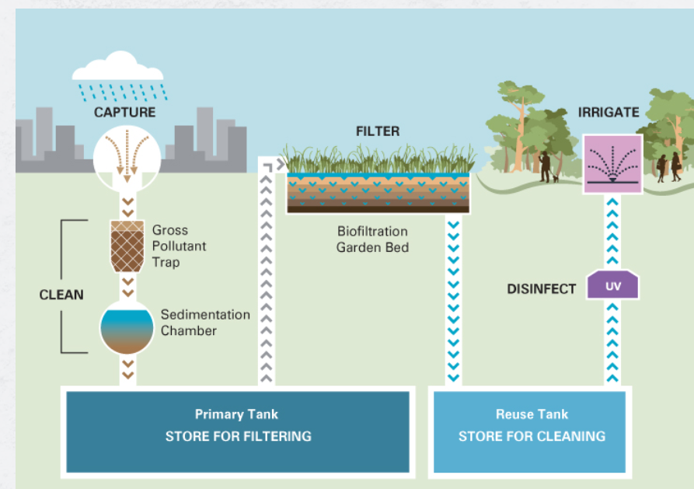

In scientific terms, water harvesting refers to collection and storage of rainwater and also other activities aimed at harvesting surface and groundwater, prevention of losses through evaporation and seepage and all hydrological studies and engineering inventions, aimed at conservation and efficient utilization of the limited water endowment of physiographic unit such as watershed. Rain is the first form of water that we know in the hydrological cycle, hence is a primary source of water for us. Rivers, lakes and groundwater are all secondary sources of water. Hence Rainwater harvesting is the activity of direct collection of rainwater that can either be stored for direct use or can be recharged into the ground water. Rainwater harvesting means to understand the value of rain and to make optimum use of rainwater at the place where it falls.

**The subsidy is as follows:**

|  |  |
| --- | --- |
| For Individual households / residential houses | upto 50% of the cost incurred or Rs. 1,00,000/- whichever is less. |
| Residential complexes and apartment buildings | upto 50% of the cost incurred or Rs. 5,00,000/- whichever is less. |
| For Commercial complexes and hospitality businesses | upto 50% of the cost incurred or Rs. 5,00,000/- whichever is less. |
| Industrial units or plot area of 1500 sq.m and above |  |

At opposite side of upparkharm, we can do cement florring like house and then can be roofed by bamboo sticks to collect the rain water big tank.

Cement cost can be saved if we use plastic sheet and then cover with meeti, and we make slanting cement boundaries only and our tank will be ready.

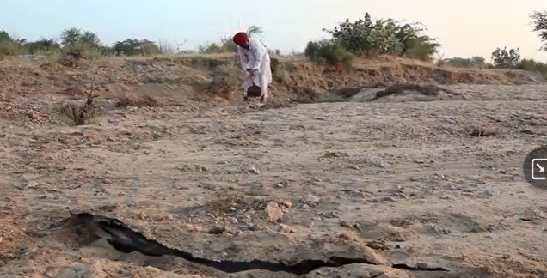



At boundaries





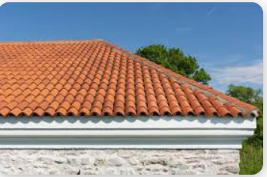

Talk to chacha for carpenter work, wooden shade work

Trampolin fractory